SoftwareAG WebMethods Messaging(Native and JMS)
Publish-and-Subscribe Model
The publish-and-subscribe model is a specific type of message-based solution in which messages are exchanged anonymously through a message broker.
Applications that produce information that needs to be shared will make this information available in specific types of recognizable documents that they publish to the message broker. Applications that require information subscribe to the document types they need.
At run time, the message broker receives documents from publishers and then distributes the documents to subscribers. The subscribing application processes or performs work using the document and may or may not send a response to the publishing application.
In a webMethods system, webMethods Integration Server or applications running on Integration Server publish documents to a messaging provider.
You can use Universal Messaging and/or Broker as messaging providers. The messaging provider then routes the documents to subscribers (webMethods messaging trigger) located on other Integration Servers. The following sections provide more detail about these components.
webMethods Components
- Integration Server
Integration Server is the central run-time component of a publish-subscribe solution. It serves as the entry point for the systems and applications that you want to integrate, and is the system’s primary engine for the execution of integration logic.
It also provides the underlying handlers and facilities that manage the orderly processing of information from resources inside and outside the enterprise. Integration Server publishes documents to and receives documents from Universal Messaging or Broker.
- webMethods Messaging Providers
The messaging provider servers as the intermediary that routes documents between publishers and subscribers. The messaging provider receives, queues, and delivers documents. It provides the infrastructure for implementing synchronous or asynchronous, message-based solutions that are built on the publish-and-subscribe model or one of its variants, request/reply or publish-and-wait.
The webMethods suite includes two messaging providers that you can use:
  - Universal Messaging
  - Broker
(Broker is deprecated)
Integration Server and the webMethods messaging providers (Universal Messaging and Broker) share a fast, efficient process for exchanging documents across the entire webMethods system.
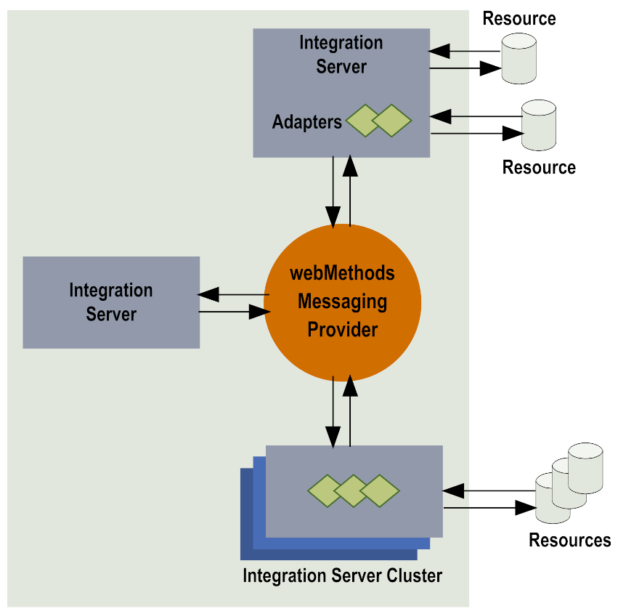

Basic Elements in the Publish-and-Subscribe Model
Documents:
Documents are objects that webMethods components use to encapsulate and exchange data. A document represents the body of data that a resource passes to webMethods components. Often it represents a business event such as placing an order (purchase order document), shipping goods (shipping notice), or adding a new employee (new employee record).
Each published document includes an envelope. The envelope is much like a header in an email message. The envelope records information such as the sender’s address, the time the document was sent, sequence numbers, and other useful information for routing and control. It contains information about the document and its transit through your webMethods system.
Publishable Document Types:
Every published document is associated with a publishable document type. A publishable document type is a named schema-like definition that describes the structure of a particular kind of document that can be published and subscribed to. An instance of a publishable document type can either be published locally within an Integration Server, or can be published to a to a messaging provider. In a publication environment that includes a messaging provider, each publishable document type is bound to a provider definition.

Triggers (webMethods Messaging Triggers):
It establish subscriptions to publishable document types. Triggers also specify the services that will process documents received by the subscription. Within a trigger, a condition associates one or more publishable document types with a service
Services:
Services are method-like units of work. They contain logic that Integration Server executes. You build services to carry out work such as extracting data from documents, interacting with back-end resources, and publishing documents to the messaging provider. When you build a trigger, you specify the service that you want to use to process the documents that you subscribe(can be called as subscription service).
Adapter Notifications:
The adapter notification publishes a document when the specified event occurs on the resource.
For example, if you are using the Adapter for JDBC and a change occurs in a database table that an adapter notification is monitoring, the adapter notification publishes a document containing data from the event and sends it to Integration Server.
Each adapter notification has an associated publishable document type. Integration Server assigns this document type the same name as the adapter notification but appends “PublishDocument” to the name.

Overview of Publishing to a webMethods Messaging Provider
Integration Server publishes documents to a webMethods messaging provider, which then routes the documents to all of the subscribers. Integration Server can publish documents to Universal Messaging, Broker, or locally within the Integration Server.
The following sections describe how Integration Server interacts with the webMethods messaging provider in these publishing scenarios:
- Publishing a document to the webMethods messaging provider.
When Integration Server sends documents to a configured webMethods Messaging Provider, Integration Server either publishes or delivers the document.
  - When the Integration Server publishes a document, it is broadcast to all subscribers. The webMethods messaging provider routes the document to all clients subscribed to that document.
  - When Integration Server delivers a document, the delivery request identifies the document recipient. The webMethods messaging provider enqueues the document for the specified client only.

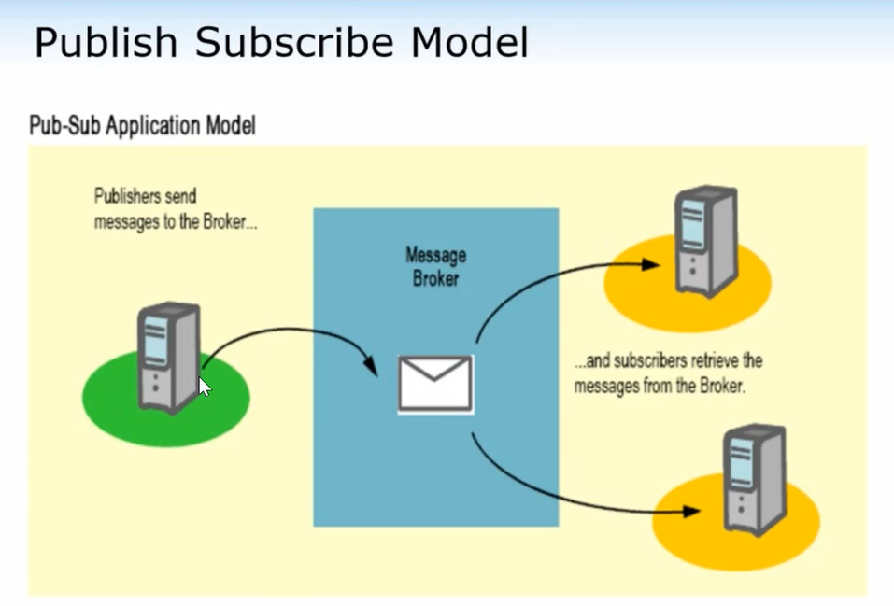

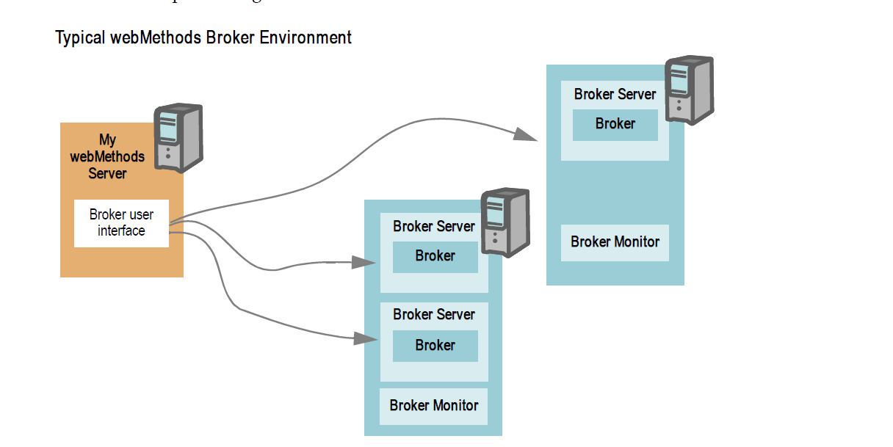

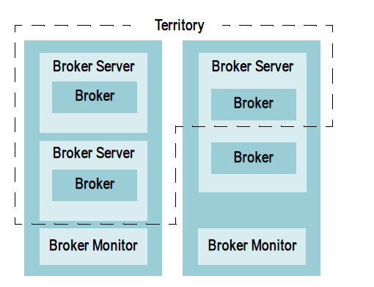

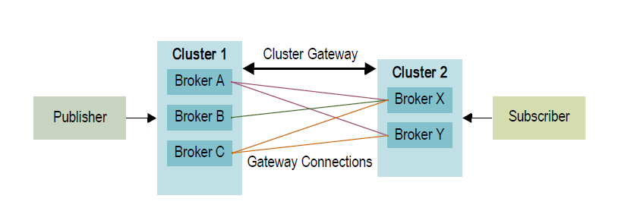

- Publishing a document to the webMethods messaging provider when the webMethods messaging provider is not available.

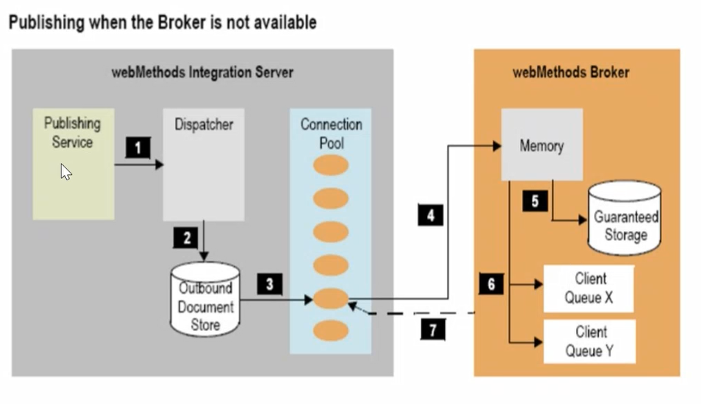

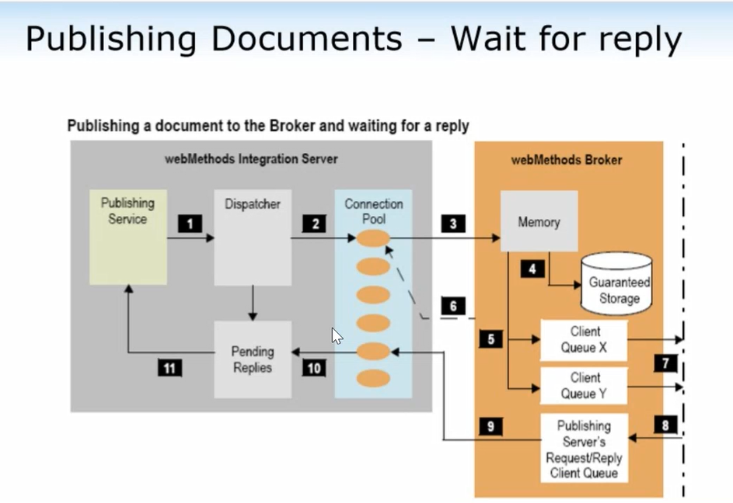

Overview of Subscribing from webMethods Messaging Provider
When webMethods messaging trigger receives and processes a document, the path a document follows on the subscriber side includes retrieving the document from the webMethods messaging provider, storing the document on Integration Server, and processing the document. The subscription path for a document depends on whether the document was published to all subscribers (broadcast) or delivered to Integration Server directly.
- The Subscribe Path for Published Documents
When a document is published or broadcast, the webMethods messaging provider enqueues a copy of the document for each subscriber.
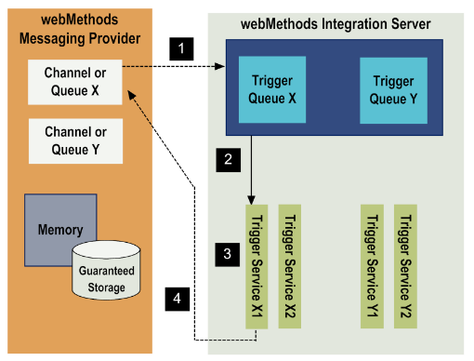

- The Subscribe Path for Delivered Documents When Using webMethods Broker
A publishing service can deliver a document by specifying the destination of the document. That is, the publishing service specifies the Broker client that is to receive the document. When the Broker receives a delivered document, it places a copy of the document in the queue for the specified client only.
Typically, documents are delivered to the default client. The default client is the Broker client created for Integration Server when Integration Server first configures its connection to the Broker.
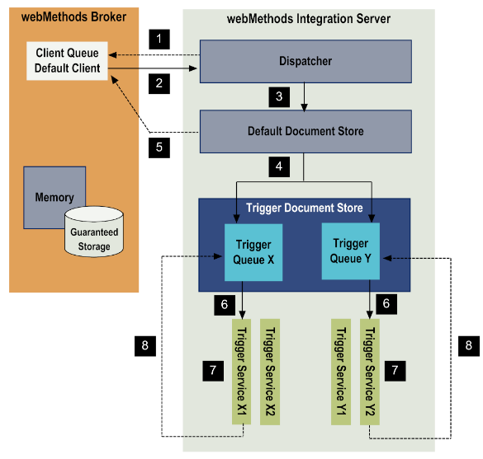

Overview of Local Publishing
Local publishing refers to the process of publishing a document within the Integration Server. Only subscribers located on the same Integration Server can receive and process the document. In local publishing, the document remains within Integration Server. There is no involvement with the webMethods messaging provider.
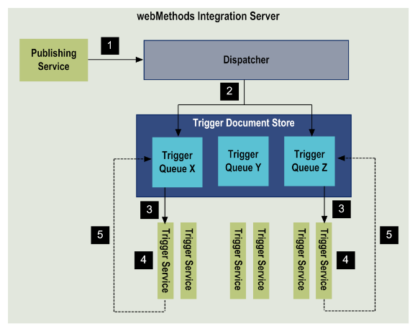

Demos:
- Publish the document to UM and Subscribe.
- Publish the document to UM and wait for the reply from Subscription service.
- Suspend the trigger and verify the publish-subscribe flow.
- JMS send and receive

Additional details:
https://documentation.softwareag.com/universal_messaging/num10-11/10-11_UM_webhelp/index.html
https://documentation.softwareag.com/universal_messaging/num10-11/10-11_Universal_Messaging_Concepts_Guide.pdf

Training course links:

webMethods Integration Basic (E611A-77E)
https://learn.softwareag.com/enrol/index.php?id=1578

webMethods Integration Essentials (E611-77E)
https://learn.softwareag.com/enrol/index.php?id=462

